

SUMMER TRAINING REPORT ON

Equity Research on Financial Services

For

Future Generali Life Insurance

By

Swati Menon

19049

*In Partial Fulfillment for the award of the degree*

Post Graduate Diploma in Management

Batch

2019-2021

**Specialization**: Finance **and** Business Analytics

New Delhi Institute of Management

50 (B&C), 60, Tughlakabad Institutional Area, New Delhi-110062

E-mail:[placement@ndimdelhi.org](mailto:placement@ndimdelhi.org) Website: [www.ndimdelhi.org](http://www.ndimdelhi.org)

SUMMER TRAINING REPORT ON

[Equity](http://www8.nationalacademies.org/cp/projectview.aspx?key=49173) Research on Financial Services

For

Future Generali Life Insurance



Under the supervision

of

Pushpender Khuteta

Submitted By- Submitted to-

Swati Menon Prof. Ravindra Chawla

19049

Certificate from the company

ACKNOWLEDGMENT

I Swati Menon student of New Delhi Institute of Management, batch 2019-2021 declare that every part of the Project Report Equity Research on Indian Financial service submitted by me is original. I was in regular contact with my faculty guide and contacted numerous times for discussing the project.

Date of project submission: 28th August 2020



Signature of the student:

Swati Menon

**CERTIFICATE OF AUTHENTICITY**

**Faculty Mentor’s Comments:**

_______________________________________________________________________________________________________________________________________________________________________________________________________________________________________________________________

Signature of Faculty guide

Name: Prof Ravindra Chawla

Table of contents

|  |  |  |
| --- | --- | --- |
| **Chapter No.** | **Topic Name** | **Page No.** |
| **Chapter 1** | **Executive Summary** | **7** |
| **Chapter 2** | **Introduction** | **8-10** |
| 2.1 Introduction to Subject | **11-14** |
| 2.2 Introduction to the Project | **15-17** |
| 2.3 Introduction to sector / Industry | **18** |
| 2.4 Introduction to Company | **19-20** |
| **Chapter 3** | **Project Details** | **22** |
| 3.1 Objective of the study |  |
| 3.2 Limitations of the study |  |
| **Chapter 4** | **Methodology** | **27-23** |
| 5.1 Data Collection Method |  |
| 5.2 Research Tools |  |
| **Chapter 5** | **Analysis & Findings** |  |
| 6.1 Fundamental Analysis | **24-37** |
| 6.2 Technical analysis | **38-44** |
| **Chapter 7** | **Conclusion & Recommendation** | **47-46** |
| **Learning** |  |
| **Limitations** |  |
| **Suggestion** |  |
| **Conclusion** | **48** |
| **Chapter 8** | **Annexures** | **49** |
| **Chapter 9** | **Bibliography** | **50** |

**Chapter 1**

Executive Summary

This project aims to do equity research on the financial sector and find out the opportunities for investment in companies in this sector where retunes can be maximized. This research will be done by using fundamental and technical analysis to see their stock prices.

As companies grow their shareholders are benefitted with a good dividend and capital appreciation on investment in equity shares of such companies. The number of companies listed in the stock exchange (BSE & NSE) has been increasing every year with new IPOs coming in the market. In India people are realizing that equity has the potential to give the highest return as compared to other investment avenues however people are not aware of how the valuation is done, they usually take tips from their relatives, friends, or brokers when they invest. It’s always a risk when you invest in equity shares in the bases of others' opinions with your hard-earned money.

The project is an attempt to explain some basic concepts that most investors take for granted but that’s crucial knowledge for a person just entering into the financial jungle.

Fundamental analysis is used to check the foundation of the company and its financial performance. Technical analysis is used to decide the right price to buy a stock so that a higher return on investment can be generated. This report starts with the fundamental analysis where EIC (economy, industry, Company) analysis of the four Companies (HDFC AMC, ICICI, SBI,) is done. The economy of India and the banking industry are analyzed based on various factors and indicators.

Finally, the conclusion and recommendations are given concerning the derived result.

This project helps to identify the best stock that an individual can invest in following the Indian Financial service sector.

**Chapter 2**

Introduction

**2.1 Introduction to the subject**

What is Equity

the value attributable to the owners of a is known as equity. The difference between assets and liabilities of the company’s balance sheet is how the book value of equity is calculated, whereas the market value of equity is calculated by the current price of the share or the value which is determined by the investors or if the valuation is done by the professional.

The value which in case of liquidation of a company, is given back to the shareholders of the company. A shareholder has ownership of a company, which means they have a stake in that company.

What is Equity Research?

the study of equities or stocks for investments is known as Equity Research. In much simpler terms, the act of gathering information such as:

* information that helps investors to decide where to put in their money
* information that traders require to understand whether to enter or exit a market position
* information that financiers (bankers and firms) need to evaluate companies.

The common stock comprises a huge amount in any company’s capital and shareholders should know whether they should stay invested in the company or sell their shares. Both, buying-side and the selling-side companies usually invest in maintaining an equity research division

The objective of the equity researcher is to give a current-day a comprehensive analysis of a company, permitting investors to make an informed decision.

The study is used by investment banks and private equity firms to evaluate the company for IPO, LBO, mergers, and others.

For an investment bank, the equity research segment produces income as buy-side firms recompence the equity research team to research into its records and analyses information.

As a separate individual, it is inefficient to do equity research, that is, to study the company, its financial statements, products, management and decide on investment. Exactly for the identical reason, individuals are working in research companies whose occupation is to do equity research and endorse companies for investment.

The application of equity research varies. Principally, equity research is used in the mutual fund's industry, investment evaluation, merger and acquisition deals, financial publications, and charitable bequests.

The objective of Equity Research

As stated before, equity research determines to study companies, analyses financials, and look at quantitative and qualitative aspects, serving investors of fluctuating degrees to make an informed decision. As the name proposes, ‘research’ plays the most significant role here. Over the years, research approaches have changed but the sole purpose of research remains the same.

The number of investors is thriving and so is the need for exploring the nature of investments. Investors wish to take calculated and informed decisions, and this is where the role of equity research begins. The drive of equity research and the researcher is diverse. To begin with, one gathers and analyses industry data and financial models of a specific company or an industry.

It also includes understanding existing market trends, both from the viewpoints of the macroeconomy and micro-economy, and report findings. Since the equity research marks exact onlookers, it is essential to tailor the findings to the audience demand.

Further, satisfactory stress is laid on the correctness of evidence. If investors take movements based on any kind of distortion or caricature, losses are tremendous and harmful to both the investor and the company. Therefore, equity analysts spend a considerable amount of time analyzing stocks and evaluating estimates.

Role of Equity Research

1. Equity Research plays a very critical role that fills the information gap between the buyers and sellers of shares.
2. The reason is that at all levels (individual or institutional) may not have the resources or the capabilities to analyses every stock.
3. Additionally, full information is not provided by the management due to which further in-efficiencies are created and stocks trade below or above the fair value.
4. Equity Research analysts spend a lot of time, energy, and expertise to analyses stocks, follow the news, talking to the management, and provide an estimate of stock valuations.
5. Also, equity research tries to identify the value stocks out of the massive ocean of stocks and help the buyers to generate profits.

**2.2 Introduction to Financial Services**

The Indian Financial service sector delivers Indian Financial service to individuals and businesses. This section of the economy entails of capital markets, insurance sector, and non-banking financial companies (NBFCs). The Financial Service business is probably the most vital sector of the economy, foremost the world in terms of paychecks and equity market capitalization, large conglomerates dominate this sector, but it also includes a diverse range of smaller companies.

Businesses in the Indian Financial service manufacturing manage money, they are the principal driver of a nation’s economy. It offers a free flow of capital and liquidity in the marketplace. When the subdivision is strong, the economy grows and corporations in this industry are better-quality able to manage risk.

The asset of the Indian Financial service subdivision is also central to the success of a country’s population. When the sector and economy are robust, consumers usually earn more. This improves their confidence and purchasing power. When they require access to credit for large purchases, they turn to the Indian Financial service sector to borrow.

**Importance of Financial Sector in our economy**

A robust financial service sector may fail, it can drag a country’s economy down. This can lead to a recession. When the financial system jumps to break down, the economy starts to suffer. Capital starts to dry up as leaders tense the reins on lending. Unemployment rises and wages may even drop, leading consumers to stop spending. To compensate, central banks decrease interest rates to try to boost economic growth. This is mainly what happened during the financial crisis that led to the great recession.

**Segments of the Indian Financial service sector**

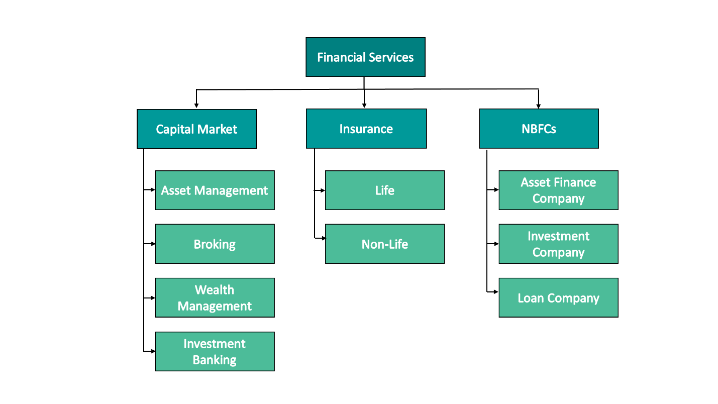

**Capital Market**

A financial market that works as a channel for demand and supply of debt and equity capital. Its frequencies the money provided by savers and depository organizations like banks, credit unions, insurance companies, etc. to borrow and investees through a diversity of financial instruments like bonds, notes, shares called securities.

A capital market is not a dense unit, but an extremely dispersed system made up of three parts stock market, bond market, and money market. It also works as an exchange for trading existing claims on capital in the form of shares.

India has scored a perfect 10 in protecting shareholders' rights on the back of reforms implemented by the Securities and Exchange Board of India (SEBI) in the World Bank's Ease of Doing Business 2020 report.

In the case of the Asset, Management industry is among the fastest-growing in the world. In March 2019, corporate investors Assets Under Management stood at Rs 9.55 lakh crore, while high net worth individuals and retail investors reached Rs 7.52 lakh crore and Rs 6.30 lakh crore, respectively. In the Asia-Pacific region, India is among the top five countries in terms of HNWIs. The value of alternative investment funds rose from Rs 13,776 crore in June 2016 to Rs 74,817 crore in June 2019.

Mutual Fund industry’s asset under management grew from Rs 10.96 trillion in October 2014 to Rs 24.54 trillion in May 2020. Inflow in India's mutual fund schemes via the Systematic Investment Plan (SIP) route reached Rs 82,453 crore in 2019. Equity mutual funds registered a net inflow of Rs 8.04 trillion by end of December 2019.

The Government of India has taken various steps to deepen reforms in the capital market, including simplification of the IPO process, which allows qualified foreign investors (QFIs) to access the Indian bond market.

**Insurance Sector**

The Indian Insurance Sector is divided into two categories – Life Insurance and Non-life Insurance. The Non-life Insurance sector is also termed as General Insurance. Both the Life Insurance and the Non-life Insurance is governed by the IRDAI (Insurance Regulatory and Development Authority of India).

The Insurance sector in India consists of a total of 57 insurance companies. Out of which 24 companies are the life insurance providers and the remaining 33 are non-life insurers. Out which there are seven public sector companies.

Life insurance companies offer coverage to the life of the individuals, whereas the non-life insurance companies offer coverage with our day-to-day living like travel, health, our car and bikes, and home insurance. Not only this, but the non-life insurance companies provide coverage for our industrial equipment as well. Crop insurance for our farmers, gadget insurance for mobiles, pet insurance, etc. are some more insurance products being made available by the general insurance companies in India. The life insurance companies have gained an investment prospectus in recent times with an idea of providing insurance along with a growth of your savings. But the general insurance companies remain reluctant to offer pure risk cover to the individuals.

**NBFCs**

Non-banking financial companies (NBFCs) play a pivotal role in the Indian financial system and have taken a great leap in the last 10 years. These financial entities have penetrated the remote areas of the country and offer credit facilities to those millions of individuals and small firms which generally are ignored by the banks.

Finance, that has rightly been termed as ‘lifeblood of business’ is scarce for many startups, small firms, and individuals as they are not able to satisfy stringent conditions set by the banks. The NBFCs have come to the rescue of such entities and given them a lifeline.

NBFCs have served the non-banking customers by pioneering into retail asset-backed lending, lending against securities and microfinance. NBFCs aspire to emerge as a one-stop-shop for all financial services. NBFCs are expected to raise their share to 19-20 percent by 2020 through the recapitalization program for the public sector. New RBI guidelines on NBFCs with regards to capital requirements, provisioning norms, and enhanced disclosure requirements are expected to benefit the sector in the long run.

**2.3 Introduction to the project**

Companies that will undergo the Equity Research are:

1.HDFC AMC

2. ICICI Lombard General Insurance Company Ltd.

3. SBI Life Insurance Company Ltd.

4. Bajaj Finance Ltd.

5. Mahindra and Mahindra Indian Financial service Ltd.

**HDFC Asset Management Company**

Is synonymous with quality investment management, expertise, and trust. Over the past two decades, we have shaped our strengths in delivering simple and accessible investment products and the average Indian household, which has led to becoming the most preferred choice for individual investors. They have offered systematic transaction further enhances appealing to their customers who are looking to invest periodically in a disciplined and risk-mitigating manner.

HDFC AMC is India’s most profitable mutual fund manager, leading in actively managed equity-oriented assets under management (AUM). Our total Mutual Fund AUM (as on March 31, 2020) of ` 3.2 Lakh Crore spans across a comprehensive suite of investment products across asset classes and scheme categories to meet the various investment objectives of a large customer base of 56 Lakh individuals and institutions.

Their principal shareholders are Housing Development Finance Corporation Limited (HDFC) and Standard Life Investments Limited which own 52.7% and 26.9% stake (as on March 31, 2020), respectively. The brand equity, goodwill, and expertise of our sponsors empower us to grow from strength to strength.

(AR 2020)

**ICICI Lombard General Insurance Company Ltd.**

Established in 2001, ICICI Lombard General Insurance Company is a joint venture between [ICICI Bank](https://en.wikipedia.org/wiki/ICICI_Bank)- India’s second-largest bank and [Fairfax Financial](https://en.wikipedia.org/wiki/Fairfax_Financial) Holdings Limited- a Indian Financial service company based in [Toronto](https://en.wikipedia.org/wiki/Toronto).

[ICICI Bank](https://en.wikipedia.org/wiki/ICICI_Bank) had a 64% stake in the venture while Fairfax had 36% in the joint venture. ICICI Lombard General Insurance is the largest private sector general insurance company in India. In fiscal 2016, ICICI Bank sold a 9.0% stake in ICICI General to its joint venture partner, Fairfax Financial Holdings, at a company valuation of ₹172.25 billion.

Following the transaction, the share ownership in ICICI Lombard General Insurance Company of [ICICI Bank](https://en.wikipedia.org/wiki/ICICI_Bank) and [Fairfax Financial](https://en.wikipedia.org/wiki/Fairfax_Financial) Holdings Limited is approximately 64% and 35%, respectively. ICICI Lombard tied up with [Karur Vysa Bank](https://en.wikipedia.org/w/index.php?title=Karur_Vysa_Bank&action=edit&redlink=1) in 2019 for selling [bancassurance](https://en.wikipedia.org/wiki/Bancassurance) products in 2019.

In August 2020, ICICI Lombard acquired [Bharti Axa General Insurance](https://en.wikipedia.org/wiki/Bharti_Axa_General_Insurance) through a [share swap deal](https://en.wikipedia.org/wiki/Stock_swap). The deal will enable Bharti AXA's current shareholders to receive 2 shares of ICICI Lombard for every 115 shares of Bharti AXA held. The merger will result in a combined annual premium worth ₹16,447 crores (US$2.3 billion).

(AR 2019-20)

**SBI Life Insurance Company Ltd.**

SBI Life Insurance is a joint venture life insurance company between [State Bank of India](https://en.wikipedia.org/wiki/State_Bank_of_India) (SBI), the largest [state-owned](https://en.wikipedia.org/wiki/Government-owned_corporation) banking and [financial services](https://en.wikipedia.org/wiki/Financial_service) company in India, and [BNP Paribas](https://en.wikipedia.org/wiki/BNP_Paribas) Cardif. BNP Paribas is a French multinational bank and Indian Financial service company with global headquarters in [Paris](https://en.wikipedia.org/wiki/Paris).

SBI has a 62.1% stake in the company and BNP Paribas Cardif owns a 22% stake. Other investors are Value Line Pte. Ltd. and MacRitchie Investments Pte. Ltd., holding a 1.95% stake each while the remaining 12% is free float stake with public investors. SBI Life Insurance has an authorized capital of ₹20 billion (US$280 million) and a paid-up capital of ₹10 billion (US$140 million).

(AR 2019-2020)

**Bajaj Finance Ltd.**

Originally incorporated as [Bajaj Auto Finance Limited](https://en.wikipedia.org/wiki/Bajaj_Auto) on March 25, 1987, the [non-bank](https://en.wikipedia.org/wiki/Non-bank) singularly focused on providing two and three-wheeler finance. After 11 years in the auto finance market, Bajaj Auto Finance Ltd launched its initial public issue of equity share and was listed on the [BSE](https://en.wikipedia.org/wiki/Bombay_Stock_Exchange) and [NSE](https://en.wikipedia.org/wiki/National_Stock_Exchange_of_India).

At the turn of the 20th century, the company ventured into the durables finance sector. In the subsequent years, Bajaj Auto Finance diversified into business and property loans as well.

In the year 2006, the company’s assets under management hit the Rs.1,000 crore mark and are currently at Rs.52,332 crore. 2010 saw the company’s registered name change from Bajaj Auto Finance Limited to Bajaj Finance Limited.

(AR 2019-2020)

|  |  |  |  |
| --- | --- | --- | --- |
| **S.no** | **Company Name** | **Intrinsic Value** | **Market Value** |
|  |
| 1 | HDFC AMC | 1073.66 | 2469.95 |  |
| 2 | ICCI Lombard General Insurance Company Ltd. | 415.58 | 1264.8 |  |
| 3 | SBI Life Insurance Company Ltd. | 260.78 | 839.2 |  |
| 4 | Bajaj Finance Ltd. | 1521.98 | 3645.55 |  |
| 5 | HDFC Life Insurance | 85.22 | 549.05 |  |
| 6 | ICICI Prudential | 73.63 | 449.25 |  |

**2.4 Introduction to the company for the Research**

**Overview of the sector**

Insurance refers to a contract between two or more parties in which one party, i.e. insurance company or the insurer, agrees to compensate for the loss or damage sustained to another party, i.e. the insured, by paying a definite amount, in exchange for an adequate consideration called as premium.

It is often represented by an insurance policy, wherein the insured gets financial protection from the insurer against losses due to the occurrence of any event which is not under the control of the insured.

Major players in this Industry are

1. LIC India
2. ICICI Prudential
3. Bajaj Allianz
4. TATA AIA
5. Aviva Life

Scope & Impact of the Industry on Indian Economy

In 2019, we all saw how ripe the insurance industry was for disruption. Although new technology has already been introduced to the market, not everyone was able to adapt to the tech-driven shift. Some insurers made an early move to use advanced tools and it’s only a matter of time before they reap the

benefits of their labor. In 2020, we can expect tech-infused insurance processes to become more commonplace. Because, in truth, the insurance industry trends show that the only way we’re going is forward.

* The life insurance premiums only had a real growth rate of 0.2% in 2018.
* The days for a single business model for insurance are over.

**Introduction to the Company**



Future Generali was founded in 2007 and is the joint venture between Future Group and Generali. The Chairman of the company is Mr. G.N Bajpai and Mr. Devi Dayal as Chief Financial Officer. There are about 74 branches all over India.

The companies Chairman is G.N Bajpai, Managing Director and CEO is Anup Rau, their Chief operating officer is Shreeraj Deshpande, their Head Corporate Sales officer is Deepak Prasad and Chief Human Resource Officer is Sunil Wariar

It offers various insurance products from the motor to lifestyle insurance like Future Generali Assured Income Plan. Future Generali Assured Money Back Plan, Future Generali Assured Wealth Plan. It also offers various assurance plans such as retirement plans and child plans.

The turnover of the company

|  |  |
| --- | --- |
| **Year** | **Amounts (Amount in Rs. ‘000)** |
| For the year ended 31st March 2019 | 1,025,824 |
| For the year ended 31st March 2018 | 786,281 |
| For the year ended March 31, 2017 | 427,973 |
| For the year ended March 31, 2016 | (52,549) |
| For the year ended March 31, 2015 | 1,480.90 |

The company has a very wide customer base with around 12.8 lakh customers from across 128 cities in India. To increase its rural penetration the company has tied up with many small and medium-sized banks in the rural areas.

Their CSR unit is called **Sneh** which focusses on health, education, and the environment.

* Their major initiatives include village adoption: An initiative with a focus on sustainable and inclusive growth of the disadvantaged families, Palghar, Maharashtra to provide access to sanitation, clean drinking water, adult education, and vocational training to the 132 tribal families residing in the village
* desktop donation drive: A pan India initiative aimed at encouraging and supporting computer education for the deprived. They have donated in Mumbai and Pune region throughout their NGO partners Pratham, Smile Foundation, Akshara Centre, Indian Development Foundation, and Vidya.
* anti-tobacco awareness workshop, autism awareness, financial literacy workshop, and self-defense education for women.
* The company extended its support to ‘Muktshala’:
* a residential facility to restore the educational rights of 80 tribal children of migrant workers at Mahad in Raigad district of Maharashtra. donates old newspapers to Indian Development Foundation (IDF) intending to promote environmental protection and support the education of underprivileged children.

**Chapter 3**

**Project Details**

**3.1 Objective of the Study**

* To identify the undervalued stocks in the selected Indian Financial service sector.
* To create a portfolio to choose the best-performing stocks among those companies and thereafter analyze the trend of stock growth or performance.

**3.2** **Limitations of the study**

* The study is restricted only to Financial Services.
* The performance of the stock is from 11th June to 19th August 2020.
* The trend change is based on assumptions.
* Limited knowledge of Technical Analysis in a short period.

**Chapter 4**

**Methodology**

For the study of this project, Large-cap and mid-cap companies are taken into consideration. List of selected companies are as follows:

1. HDFC AMC
2. ICICI Lombard General Insurance Company Ltd.
3. SBI Life Insurance Company Ltd.
4. Bajaj Finance Ltd.
5. Mahindra and Mahindra Indian Financial service Ltd.
6. ICICI Prudential

**4.1 Data Collection Method**

**Secondary**

This research includes the material collected extensively through secondary data. To analyses the performance of the selected companies (i.e**.** HDFC AMC, ICICI Lombard General Insurance Company Ltd., SBI Life Insurance Company Ltd., Bajaj Finance Ltd.

The details of these companies have been collected through the websites of these companies followed by taking the stock prices of these companies from yahoo finance. The stock price has been taken from the period 11th June to 19th August 2020.

This report includes tools like Fundamental and Technical Analysis that has been used to evaluate the best performing stock among the portfolio created. The analysis includes the use of ratios, candlestick charts, and graphs to identify the trend of the stock over some time.

**4.2 Research Tools**

* Annual Report of the companies
* Company Corporate Presentations
* Industry Reports
* Live Market Report
* Statistical data

The objective is to forecast the future performance of companies and therefore inform prospective investors.

For this drive, fundamental analysis has been done to see analyses companies’ future performance founded on existing trends and future forecasts. Fundamental Analysis is done to see how the companies’ assets are valued and have an opportunity to grow. Industry analysis is also done to understand the working of the industry.

**Chapter 5**

**Analysis and Findings**

Fundamental Analysis

In the fundamental approach, an effort is made to examine numerous fundamental or rudimentary factors that affect the risk-return of the securities. The determination here is to categorize those securities that one observes as mispriced in the stock market. The hypothesis, in this case, is that the 'market price' of security and the price as acceptable by its fundamental factors called 'intrinsic value' is dissimilar and the marketplace delivers a prospect for a perceptive investor to notice such discrepancy.

In the world of investments, a firm’s price-to-earnings ratio, or P/E ratio, is an amount of its stock price comparison to its incomes. If you’re trying to regulator whether a stock is a good investment, the P/E ratio can benefit you a measure that future direction of the stock and whether the price is, comparatively speaking, high or low associated with the past or other businesses in the same sector.

Dissimilar industries have diverse P/E ratio ranges that are well-thought-out normal for their industry group.

For this study purpose, the industry P/E ratio for the Indian Financial service sector has been calculated by captivating the average of the companies selected for the valuation

**5.2 Procedure of the research**

We will be investing Rs.1 Cr on 20th August by researching the stock prices from 11th June to 19th August 2020.

1. **STEP 1**

**As of now, we have six companies, the first thing we will check is their P/E ratios.**

|  |  |  |  |
| --- | --- | --- | --- |
| **S.no** | **Company Name** | **P/E Ratio** | **Status** |
|  |
| 1 | HDFC AMC | 56.36 | Under Valued |  |
| 2 | ICICI Lombard General Insurance Company Ltd. | 45.13 | Under Valued |  |
| 3 | SBI Life Insurance Company Ltd. | 49.20 | Under Valued |  |
| 4 | Bajaj Finance Ltd. | 48.35 | Under Valued |  |
| 5 | HDFC Life Insurance | 86.76 | Overvalued |  |
| 6 | ICICI Prudential | 65.46 | Overvalued |  |
| Industry Average | | 58.54333 |  |  |

We can understand that the average of the 6 businesses taken is 58.54, which has been taken as the industry average.

After this, all the companies have been associated with the industry average P/E ratio to see which of these businesses are overvalued and undervalued. Four out of six businesses are undervalued.

For further analysis after looking at the P/E table, Valuation of HDFC AMC, ICCI Lombard General Insurance Company Ltd., SBI Life Insurance Company Ltd., and Bajaj Finance Ltd. will be done.

**From the above table, we’ll reject HDFC Life Insurance and ICICI Prudential because their shares are overvalued.**

**For further research, the selected companies are HDFC AMC, ICICI Lombard General Insurance Company Ltd., SBI Life Insurance Company Ltd., and Bajaj Finance Ltd.**

1. **STEP 2**

HPR Calculations of all the companies selected

Stock prices of companies from the National Stock Exchange

From the period 11th June to 19th August’2020

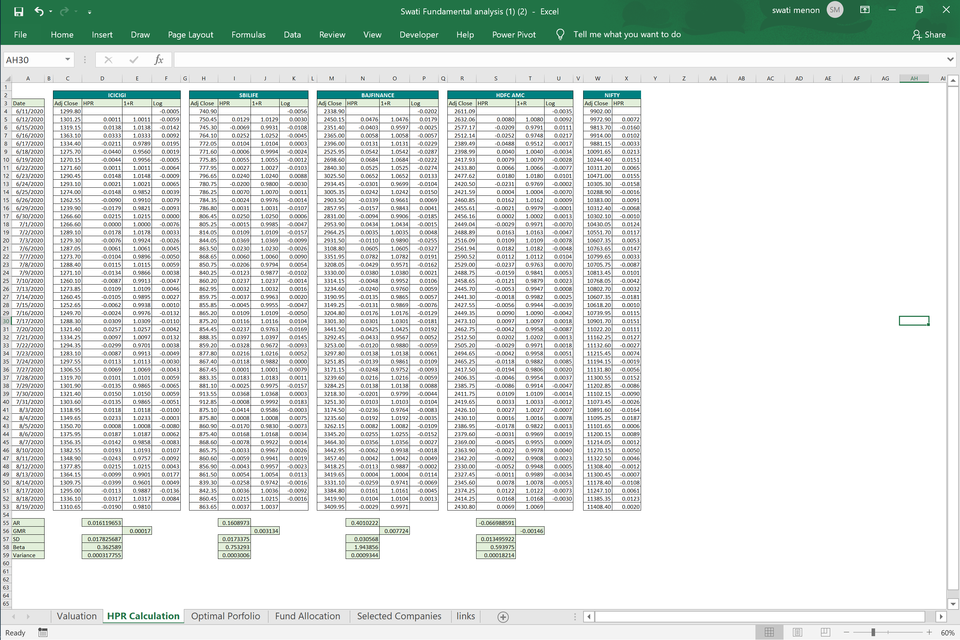

1. **STEP 3**

For the next step, we calculate the Holding Period Rate (HPR) of all the four companies as shown in step 2, after calculating the HPR we then calculate the BETA of these companies to assess the systematic risk of the companies.

Beta is a measure of [systematic risk](https://www.investopedia.com/terms/s/systematicrisk.asp) of a security or portfolio compared to the market as a whole.

Beta for an individual stock can only provide an investor with an approximation of how much risk the stock will add to a (presumably) diversified portfolio.

Types of Beta Values

* Beta Value Equal to 1.0

If a stock has a beta of 1.0, it indicates that its price activity is strongly correlated with the market. A stock with a beta of 1.0 has systematic risk.

* Beta Value Less Than One

A beta value that is less than 1.0 means that the security is theoretically less volatile than the market.

* Beta Value Greater Than One

A beta that is greater than 1.0 indicates that the security's price is theoretically more volatile than the market. For example, if a stock's beta is 1.2, it is assumed to be 20% more volatile than the market.

**We are aiming to get the beta to be less than One**

**From the data derived we can see that the Beta of Bajaj is more than 1 which shows that the stock prices of Bajaj are highly volatile therefore it’s better to not invest in Bajaj Finance Ltd.**

|  |  |  |  |  |
| --- | --- | --- | --- | --- |
|  |  | **HPR** | | |
| Date |  | ICICI | SBI | HDFC |
| 6/11/2020 |  |  |  |  |
| 6/12/2020 |  | 0.00112 | 0.01289 | 0.00803 |
| 6/15/2020 |  | 0.01376 | -0.00686 | -0.02086 |
| 6/16/2020 |  | 0.03332 | 0.02522 | -0.02523 |
| 6/17/2020 |  | -0.02105 | 0.01040 | -0.04882 |
| 6/18/2020 |  | -0.04399 | -0.00058 | 0.00397 |
| 6/19/2020 |  | -0.00435 | 0.00551 | 0.00790 |
| 6/22/2020 |  | 0.00114 | 0.00271 | 0.00657 |
| 6/23/2020 |  | 0.01482 | 0.02404 | 0.01800 |
| 6/24/2020 |  | 0.00205 | -0.01996 | -0.02305 |
| 6/25/2020 |  | -0.01477 | 0.00704 | 0.00045 |
| 6/26/2020 |  | -0.00899 | -0.00242 | 0.01621 |
| 6/29/2020 |  | -0.01794 | 0.00312 | -0.00213 |
| 6/30/2020 |  | 0.02153 | 0.02497 | 0.00022 |
| 7/1/2020 |  | 0.00000 | -0.00149 | -0.00290 |
| 7/2/2020 |  | 0.01776 | 0.01093 | 0.01628 |
| 7/3/2020 |  | -0.00760 | 0.03685 | 0.01093 |
| 7/6/2020 |  | 0.00606 | 0.02304 | 0.01822 |
| 7/7/2020 |  | -0.01037 | 0.00596 | 0.01116 |
| 7/8/2020 |  | 0.01154 | -0.02061 | -0.02375 |
| 7/9/2020 |  | -0.01343 | -0.01234 | -0.01592 |
| 7/10/2020 |  | -0.00865 | 0.02374 | -0.01209 |
| 7/13/2020 |  | 0.01091 | 0.00320 | -0.00527 |
| 7/14/2020 |  | -0.01052 | -0.00371 | -0.00180 |
| 7/15/2020 |  | -0.00619 | -0.00454 | -0.00563 |
| 7/16/2020 |  | -0.00236 | 0.01092 | 0.00898 |
| 7/17/2020 |  | 0.03089 | 0.01156 | 0.00970 |
| 7/20/2020 |  | 0.02569 | -0.02371 | -0.00419 |
| 7/21/2020 |  | 0.00972 | 0.03967 | 0.02020 |
| 7/22/2020 |  | -0.02990 | -0.03281 | -0.00291 |
| 7/23/2020 |  | -0.00869 | 0.02165 | -0.00421 |
| 7/24/2020 |  | 0.01126 | -0.01185 | -0.01179 |
| 7/27/2020 |  | 0.00694 | 0.00006 | -0.01937 |
| 7/28/2020 |  | 0.01006 | 0.01833 | -0.00461 |
| 7/29/2020 |  | -0.01349 | -0.00255 | -0.00856 |
| 7/30/2020 |  | 0.01498 | 0.03683 | 0.01090 |
| 7/31/2020 |  | -0.01347 | -0.00077 | 0.00328 |
| 8/3/2020 |  | 0.01178 | -0.04135 | 0.00267 |
| 8/4/2020 |  | 0.02328 | 0.00080 | 0.00165 |
| 8/5/2020 |  | 0.00078 | -0.01701 | -0.01776 |
| 8/6/2020 |  | 0.01869 | 0.01684 | -0.00308 |
| 8/7/2020 |  | -0.01424 | -0.00777 | -0.00445 |
| 8/10/2020 |  | 0.01932 | -0.00328 | -0.00215 |
| 8/11/2020 |  | -0.02434 | -0.00595 | -0.00918 |
| 8/12/2020 |  | 0.02146 | -0.00430 | -0.00521 |
| 8/13/2020 |  | -0.00994 | 0.00537 | -0.00109 |
| 8/14/2020 |  | -0.03988 | -0.02577 | 0.00780 |
| 8/17/2020 |  | -0.01126 | 0.00363 | 0.01221 |
| 8/18/2020 |  | 0.03174 | 0.02149 | 0.01685 |
| 8/19/2020 |  | -0.01905 | 0.00372 | 0.00686 |
|  |  |  |  |  |
| Avg monthly HPR |  | 0.000328973 | 0.003283619 | -0.001367114 |

We then calculate the Average Monthly HPR for the selected companies.

1. **STEP 4**

**Optimal Portfolio**

**After the calculation of average HPR,**

**we further calculate Variance-Covariance Matrix**

|  |  |  |
| --- | --- | --- |
| **(x-meanx) Here x is the HPR** | | |
| ICICI | SBI | HDFC |
|  |  |  |
| 0.02016 | 0.00961 | 0.00940 |
| 0.03280 | -0.01015 | -0.01949 |
| 0.05236 | 0.02194 | -0.02387 |
| -0.00201 | 0.00712 | -0.04745 |
| -0.02494 | -0.00387 | 0.00534 |
| 0.01470 | 0.00222 | 0.00926 |
| 0.02019 | -0.00058 | 0.00793 |
| 0.03387 | 0.02075 | 0.01937 |
| 0.02110 | -0.02324 | -0.02169 |
| 0.00428 | 0.00376 | 0.00182 |
| 0.01006 | -0.00570 | 0.01758 |
| 0.00111 | -0.00016 | -0.00076 |
| 0.04058 | 0.02169 | 0.00159 |
| 0.01905 | -0.00477 | -0.00153 |
| 0.03681 | 0.00764 | 0.01764 |
| 0.01145 | 0.03357 | 0.01230 |
| 0.02511 | 0.01976 | 0.01959 |
| 0.00868 | 0.00268 | 0.01252 |
| 0.03059 | -0.02389 | -0.02238 |
| 0.00562 | -0.01563 | -0.01455 |
| 0.01039 | 0.02046 | -0.01073 |
| 0.02996 | -0.00009 | -0.00390 |
| 0.00853 | -0.00699 | -0.00043 |
| 0.01286 | -0.00782 | -0.00427 |
| 0.01669 | 0.00764 | 0.01035 |
| 0.04994 | 0.00827 | 0.01106 |
| 0.04474 | -0.02699 | -0.00282 |
| 0.02877 | 0.03639 | 0.02157 |
| -0.01086 | -0.03610 | -0.00154 |
| 0.01036 | 0.01836 | -0.00284 |
| 0.03031 | -0.01513 | -0.01042 |
| 0.02598 | -0.00323 | -0.01800 |
| 0.02911 | 0.01505 | -0.00325 |
| 0.00556 | -0.00583 | -0.00719 |
| 0.03403 | 0.03355 | 0.01227 |
| 0.00558 | -0.00405 | 0.00464 |
| 0.03082 | -0.04464 | 0.00403 |
| 0.04232 | -0.00248 | 0.00302 |
| 0.01983 | -0.02030 | -0.01639 |
| 0.03774 | 0.01356 | -0.00171 |
| 0.00480 | -0.01105 | -0.00309 |
| 0.03836 | -0.00656 | -0.00079 |
| -0.00529 | -0.00923 | -0.00781 |
| 0.04051 | -0.00758 | -0.00384 |
| 0.00910 | 0.00208 | 0.00027 |
| -0.02083 | -0.02905 | 0.00917 |
| 0.00779 | 0.00035 | 0.01358 |
| 0.05079 | 0.01820 | 0.01821 |
| 0.00000 | 0.00044 | 0.00822 |

1. **STEP 5**

**Variance-Covariance Matrix**

|  |  |  |  |
| --- | --- | --- | --- |
| **Variance-Covariance Matrix** | | | |
| **Company** | **ICICI** | **SBI** | **HDFC** |
| ICICI | 0.000232656 | 2.77423E-05 | 4.04997E-06 |
| SBI | 2.77423E-05 | 0.000100883 | 2.60057E-05 |
| HDFC | 4.04997E-06 | 2.60057E-05 | 6.11291E-05 |
|  |  |  |  |
| Avg monthly HPR | 0.000328973 | 0.003283619 | -0.001367114 |

**We use MMULT function to make the matrix which will be further used in Optimal Portfolio**

|  |  |
| --- | --- |
| **Optimal Portfolio** | **Maximum Return** |
| **ICICI** | **0.9** |
| **SBI** | **0.1** |
| **HDFC** | **0** |
| **SUM** | 1 |
| **Risk Free Rate=** | 0.50% |
| **Expected Return=** | 0.06% |
| **Standard Deviation=** | 1.39% |
| **Sharpe Ratio=** | **-0.313780343** |

We now use the solver function to get the appropriate ratios for the companies that we have selected.

We see that the ratio has been divided between ICICI Lombard and SBI Life Insurance Ltd. and has eliminated HDFC.

1. **STEP 6**

**Fund allocation**

|  |  |  |  |  |  |  |
| --- | --- | --- | --- | --- | --- | --- |
| **TABLE 1** | | | | | | |
| **S.no** | **Company** | **Per-share price** | **Allocation Ratio** | **No. of shares** | **Fund allocated** | **Total Amount** |
|  |
| 1 | **ICICI Lombard General Insurance Company Ltd.** | ₹ 1,310.65 | **0.9** | 6866 | ₹ 9,000,000.00 | ₹ 8,998,922.90 |  |
| 2 | **SBI Life Insurance Company Ltd.** | ₹ 863.65 | **0.1** | 1158 | ₹ 1,000,000.00 | ₹ 1,000,106.70 |  |
|  |  |  |  |  |  | **₹ 9,999,029.60** |  |

We now have prepared the table of the selected companies where we will invest Rs. 1 Cr. In the ratio of 0.9 for ICICI Lombard General Insurance Company Ltd. and 0.1 for SBI Life Insurance Company Ltd.

|  |  |
| --- | --- |
| **TABLE 2** | |
| **Total fund** | **₹ 10,000,000.00** |
| **Amount Invested** | **₹ 9,999,029.60** |
| **Remaining Amount** | **₹ 970.40** |

So the portfolio shows that we should Invested Rs. 9,999,029.60 in total with a bifurcation of Rs.8,998,922.90 in ICICI Lombard General Insurance Company Ltd. and Rs. 1,000,106.70 in SBI Life Insurance Company Ltd.

**Excel formulas used for the calculation**

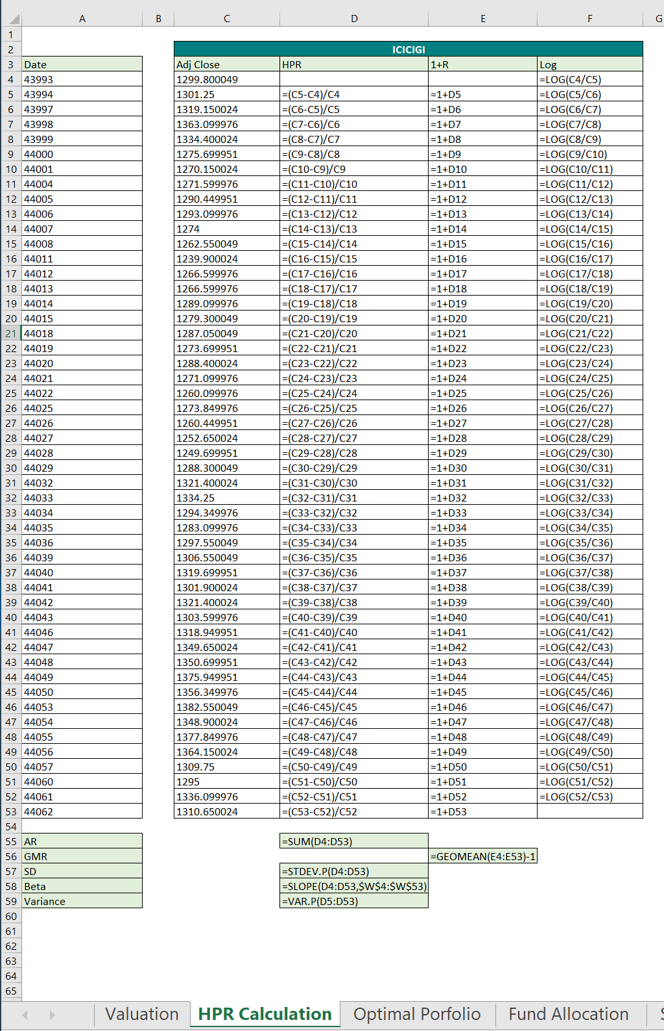

**Excel calculations of Average Monthly HPR**

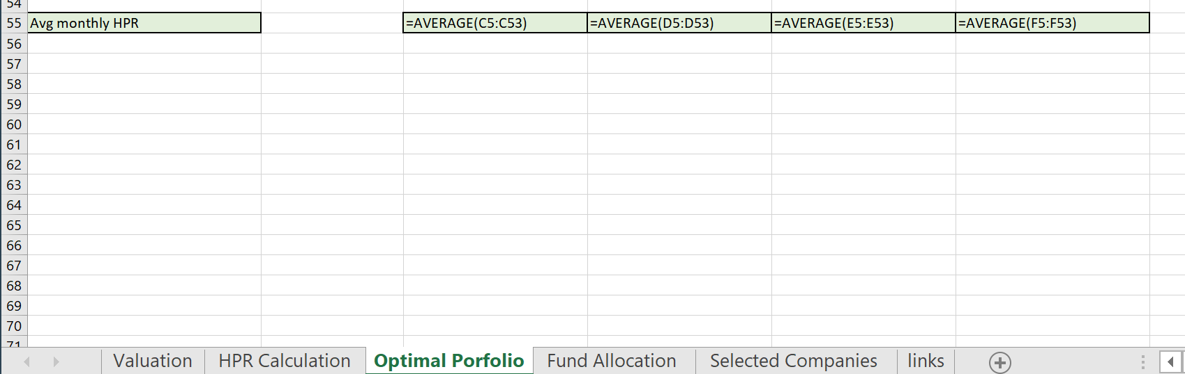

**The next method is using the calculation (x-meanX) where the value of x is the average HPR**

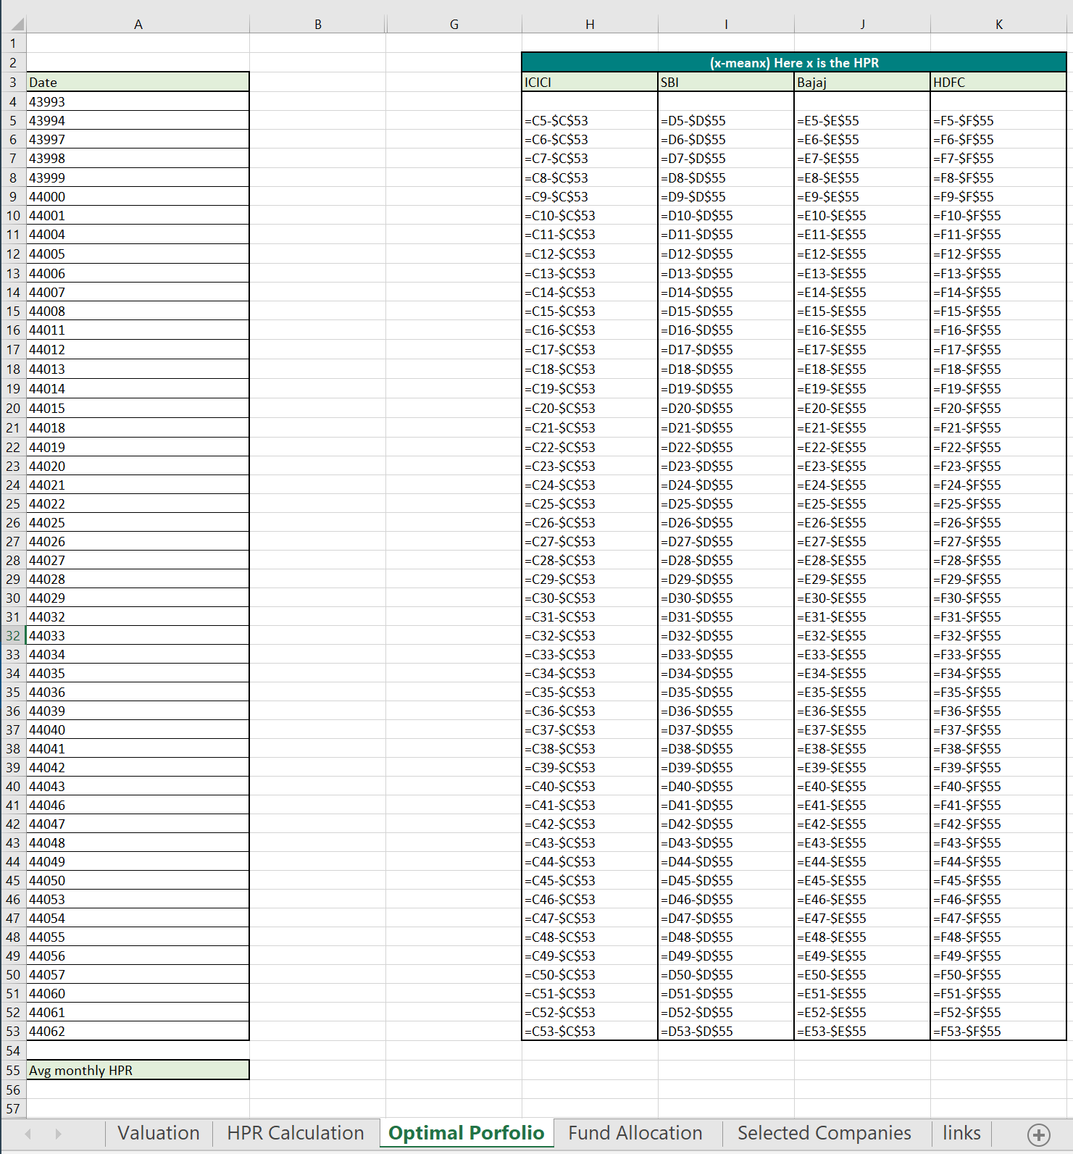

|  |  |  |  |
| --- | --- | --- | --- |
| **Variance-Covariance Matrix** | | | |
| **Company** | **ICICI** | **SBI** | **HDFC** |
| ICICI | =MMULT(TRANSPOSE(G5:I53),G5:I53)/(COUNT(G5:I53)-1) | =MMULT(TRANSPOSE(G5:I53),G5:I53)/(COUNT(G5:I53)-1) | =MMULT(TRANSPOSE(G5:I53),G5:I53)/(COUNT(G5:I53)-1) |
| SBI | =MMULT(TRANSPOSE(G5:I53),G5:I53)/(COUNT(G5:I53)-1) | =MMULT(TRANSPOSE(G5:I53),G5:I53)/(COUNT(G5:I53)-1) | =MMULT(TRANSPOSE(G5:I53),G5:I53)/(COUNT(G5:I53)-1) |
| HDFC | =MMULT(TRANSPOSE(G5:I53),G5:I53)/(COUNT(G5:I53)-1) | =MMULT(TRANSPOSE(G5:I53),G5:I53)/(COUNT(G5:I53)-1) | =MMULT(TRANSPOSE(G5:I53),G5:I53)/(COUNT(G5:I53)-1) |
|  |  |  |  |
| Avg monthly HPR | 0.000328972509885589 | 0.00328361863082092 | -0.00136711410038608 |

|  |  |
| --- | --- |
| **Optimal Portfolio** | **Maximum Return** |
| **ICICI** | **0.900000000000008** |
| **SBI** | **0.1** |
| **HDFC** | **0** |
| **SUM** | =SUM(U34:U36) |
| **Risk-Free Rate=** | 0.005 |
| **Expected Return=** | =MMULT(N39:P39,U34:U36) |
| **Standard Deviation=** | =SQRT(MMULT(MMULT(TRANSPOSE(U34:U36),$N$35:$P$37),U34:U36)) |
| **Sharpe Ratio=** | **=(U39-U38)/U40** |

**6.2 TECHNICAL ANALYSIS**

1) Rounding bottom

A chart pattern used in technical analysis, which is identified by a series of price movements that, when graphed, form the shape of a "U". Rounding bottoms are found at the end of extended downward trends and signify a reversal in long-term price movements. This pattern's time frame can vary from several weeks to several months and is deemed by many traders as a rare occurrence.

BREAKING DOWN 'Rounding Bottom'

A rounding bottoms look similar to the cup and handle pattern, but does not experience the temporary downward trend of the "handle" portion. The initial declining slope of a rounding bottom indicates an excess of supply, which forces the stock price down. The transfer to an upward trend occurs when buyers enter the market at a low price, which increases the demand for the stock. Once the rounding bottom is complete, the stock breaks out and will continue in its new upward trend.

2) Cup with handle

A pattern on bar chart resembling a cup with a handle. The cup is in the shape of a "U" and the handle has a slight downward drift. The right-hand side of the pattern has a low trading volume.

BREAKING DOWN 'Cup and Handle'

A couple of points on trying to detect cup and handles: Length - Generally, cups with longer and more "U" shaped bottoms, the stronger the signal. Avoid cups with a sharp "V" bottoms. Depth - Ideally, the cup should not be too deep. Also, avoid handles that are too deep since the handles should form in the top half of the cup pattern. Volume - Volume should dry up on the decline and remain lower than average in the base of the bowl. It should then increase when the stock finally starts to make its move back up to test the old high. Retest (of old high) - doesn't have a touch or come within a few ticks of the old high. However, the further the top of the handle is away from the highs, the more significant the breakout needs to be

3) Head and Shoulder Top

In technical analysis, a head and shoulders pattern describes a specific chart formation that predicts a bullish-to-bearish trend reversal. The head and shoulders pattern is believed to be one of the most reliable trend reversal patterns. It is one of several top patterns that signal, with varying degrees of accuracy, that an upward trend is nearing its end.

BREAKING DOWN 'Head and Shoulders Pattern'

This pattern is comprised of three parts:

1. After a long bullish trend, the price rises to a peak and subsequently declines to form a trough.

2. The price rises again to form a second high substantially above the initial peak and declines again.

3. The price rises a third time, but only to the level of the first peak, before declining once more.

The first and third peaks are shoulders, and the second peak forms the head. The line connecting the first and second troughs is called the neckline.

Head and shoulders patterns can also signal that a downward trend is about to reverse into an upward trend. In this case, the stock price reaches three consecutive lows, separated by temporary rallies. Of these, the second trough is the lowest (the head) and the first and third are slightly shallower (the shoulders). The final rally after the third dip signals that the bearish trend has reversed and prices are likely to keep moving up.

4) Head and shoulder Bottom

An inverse head and shoulders is a chart pattern used in technical analysis to predict the reversal of a current downtrend. This pattern is identified when the price action of security meets the following characteristics:   
  
1. The price falls to a trough and then rises.   
2. The price falls below the former trough and then rises again.   
3. Finally, the price falls again, but not as far as the second trough.   
  
Once the final trough is made, the price heads upward toward the resistance found near the top of the previous troughs. Investors typically enter into a long position when the price rises above the resistance of the neckline. The first and third troughs are considered shoulders, and the second peak forms the head.

BREAKING DOWN 'Inverse Head and Shoulders'

As you can see from the chart above, a move above the resistance, also known as the neckline, is used as a signal of a sharp move higher. Many traders will watch for a large spike in volume to confirm the validity of the breakout. This pattern is the opposite of the popular head and shoulders pattern but is used to predict shifts in a downtrend rather than an uptrend.

5) Double Top Pattern

A double top is a term used in technical analysis to describe the rise of a stock, a drop, another rise to the same level as the original rise, and finally another drop. The double top looks like the letter "M". The twice touched high is considered a resistance level.

**Technical Analysis using Candlestick pattern in our portfolio.**

**1.Bajaj Finance Ltd.**

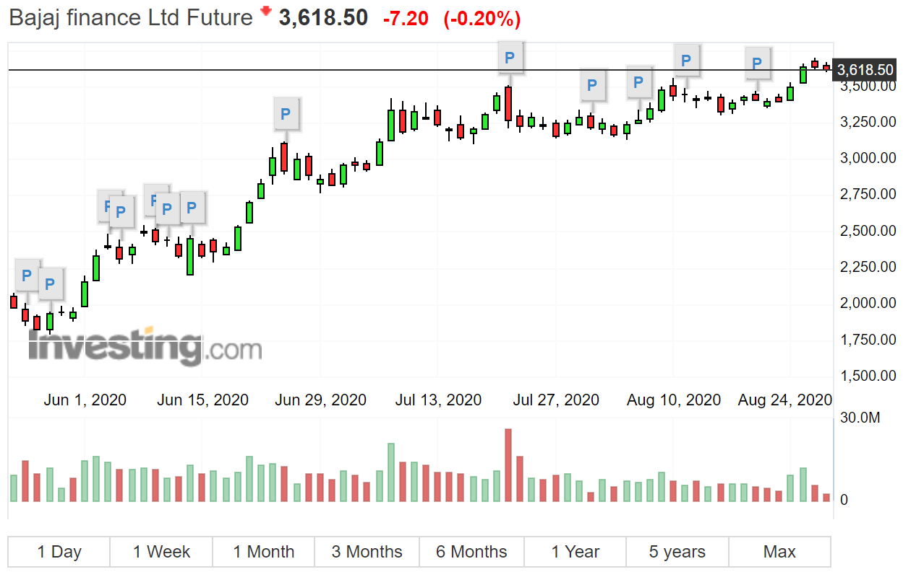

The chart shows Three Inside Up

Indication Bullish reversal

Reliability High

Description This pattern is a more reliable addition to the standard Harami pattern.

A Bullish Harami pattern occurs in the first two candles.

The third candle is a higher close than the second candle and the confirmation of the bullish trend reversal.

**2.HDFC AMC**

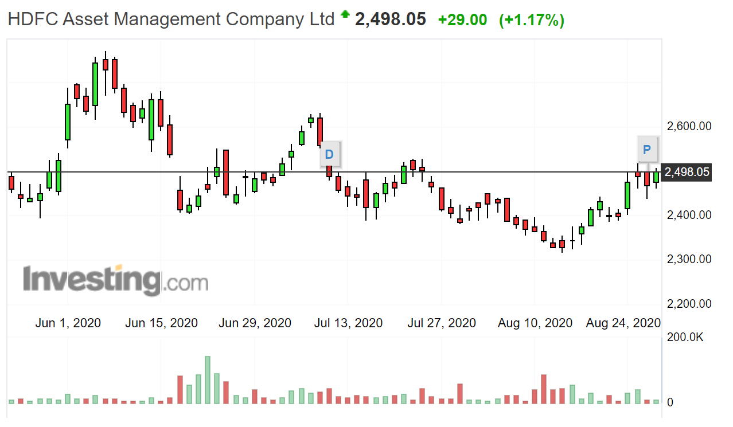

The chart shows Two Crows

It has a Bearish reversal Indication

During an uptrend, the close of a candle is lower after an opening gap upwards. This is followed by another recolor candle that fills the first one. The two crows pattern suggests the erosion of the uptrend and foreshadows a trend reversal.

**3. SBI Life Insurance Company Ltd.**

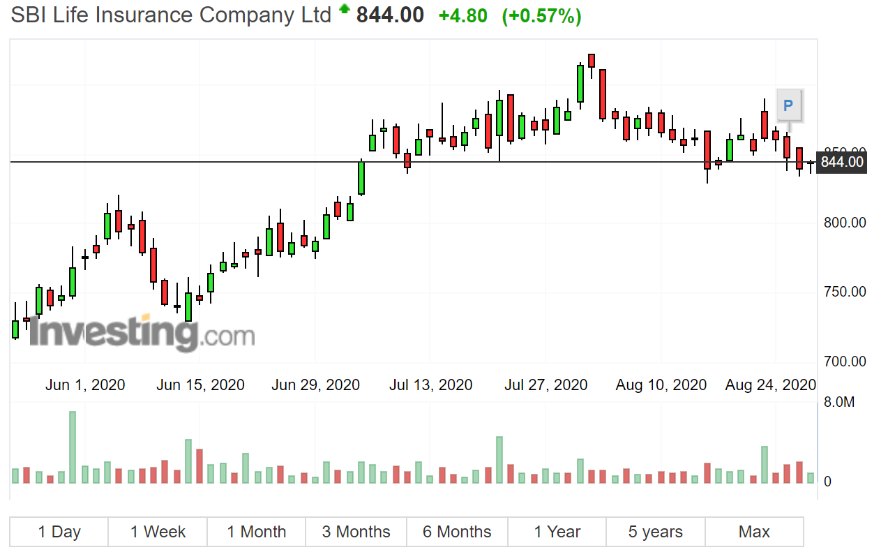

The chart shows Bullish Engulfing

It has a Bullish reversal

During a downtrend, the Bullish Engulfing depicts an opening at a new low and closes at or above the previous candle’s open. This signifies that the downtrend has lost momentum and the bulls may be gaining strength.

Factors increasing the pattern’s effectiveness are:

1. The first candlestick has a small real body and the second has a large real body.

2. The pattern appears after the protracted or very fast move.

3.Heavy volume on the second real body.

4. The second candlestick engulfs more than one real body.

**4. ICICI Lombard General Insurance Company Ltd.**

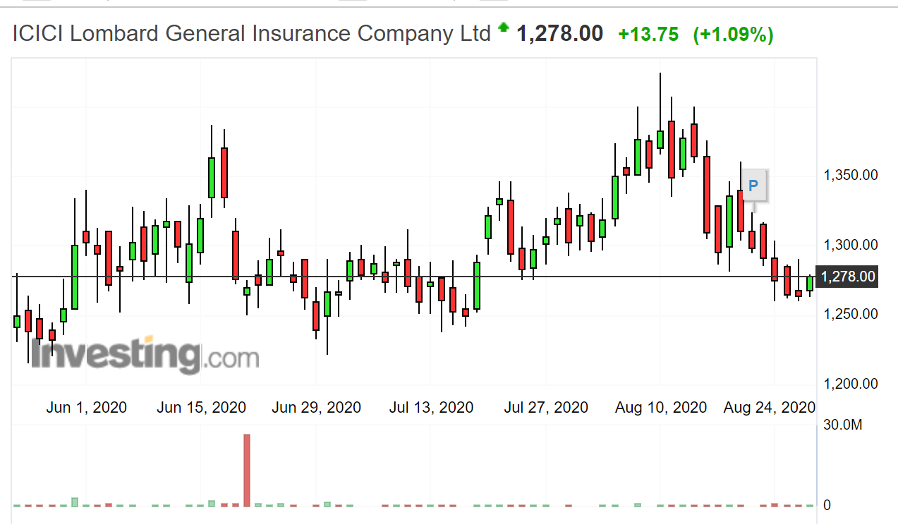

The chart shows Falling Black Crows

The companies chart shows Bearish reversal indication

During an uptrend, three long candles occur with consecutively lower closes. This pattern suggests that the market has been at a high price for too long and investors are beginning to compensate for it.

**From this, we can see that Technical analysis does differ from the fundamental analysis since both of them show different indications to the investors.**

**Technical analysis showed the investors the short-term investment opportunities as to where they should invest whereas fundamental analysis shows how strong the foundation of the company is.**

**Chapter 7**

**Learning**

1. How to read the technical charts for the purpose of trading
2. Understanding the markets, seeing how international and national news affects the stock prices
3. Learning how to create Equity portfolios
4. The issues that arise in the stock market due to COVID-19 in the Indian markets as well as the international markets

**Limitation**

1. The company did not share their financial details, since the company was not listed it was more difficult to get detailed information about them
2. The virtual experience was new but there were a lot of things that we missed out such as experiencing the work environment and the fixed timings that bound us to a decorum.

**Recommendations**

After doing the research we see that there where many parameters to Reject and Select the companies listed as follows:

1. Comparing the P/E ratio with the industry average and determining if the prices were undervalued or overvalued
2. Undervalued and Overvalued stocks: Undervalued stocks are suggested for investment:

|  |  |
| --- | --- |
| **Under Valued** | **Over Valued** |
| 1. HDFC AMC | 1. ICICI Prudential |
| 1. ICCI Lombard General Insurance Company Ltd. | 1. HDFC Life Insurance |
| 1. SBI Life Insurance Company Ltd. |  |
| 1. Bajaj Finance Ltd. |  |

1. Calculating the Beta of each company to see which is the most volatile of all, such as Bajaj Finance Ltd. had a Beta of 1.94 which is significantly high therefore for the further process, we rejected the company for further study.

**Conclusion**

1. Even though there are some universal principles and rules that can be applied, it must be remembered that technical analysis is more an art form than a science. As an art form, it is subject to explanation.
2. After analyzing the financial statements, data, and technical charts of companies under the Indian Financial service sector, 2 companies are recommended or investment to earn higher returns based on Fundamental and Technical Analysis.

**Chapter 8**

**Annexure**

**Chapter 9**

**Bibliography**

* www.moneycontrol.com
* www.equitymaster.com
* Websites of HDFC AMC, ICICI, SBI and Bajaj Finance
* www.financialexpress.com
* [www.icharts.in](http://www.icharts.in)
* [www.ibe.org](http://www.ibe.org)
* Website of NSE
* [www.bloombergquit.com](http://www.bloombergquit.com)
* www.attainix.com